

StARRS Project Report 2023 - 2025

Authors: Dr. James Lawrence, Dr. Stewart Agar, Dr. Anthony Carpenter

V2.0

30 January 2026

Version History

|  |  |  |  |  |
| --- | --- | --- | --- | --- |
| Version | Date | Revision | Author | Approval |
| 0.1 | 03 May 2025 | Initial Draft | Anthony Carpenter, Stewart Agar, James Lawrence | - |
| 1.0 | 07 July 2025 | Draft | Anthony Carpenter, Stewart Agar | - |
| 2.0 | 30 January 2026 | Draft  StARRS-Ground Complete | Anthony Carpenter | - |
|  |  |  |  |  |
|  |  |  |  |  |
|  |  |  |  |  |

Contents

Terminology 6

List of Figures 7

1. Executive Summary 8

1.1 Project Overview 8

1.2 Key Components 8

1.3 Achievements 8

1.4 Opportunities 9

2. Introduction 10

2.1 Project Background 10

2.2 Research Team 10

2.3 Technical Approach 10

3. Supporting Documentation 11

3.1 Supporting Documentation for StARRS-Cloud 11

3.2 Supporting Documentation for StARRS-Ground 11

4. Background: Multi-Temporal InSAR 13

4.1 Available InSAR Datasets 14

5. Context and Motivation 15

5.1 Nuclear Decommissioning Challenges 15

5.2 Monitoring Technologies 15

5.2.1 Satellite Systems 15

5.2.2 UAV Systems 15

5.3 Technical Background 15

5.3.1 Software Automation 15

5.4 Integrated Approach 16

6. STARRS-Cloud 17

6.1 Project Scope and Objectives 17

6.2 Cloud Environment 17

6.2.1 Design Considerations 18

6.3 System Architecture 18

6.4 User Interface 20

6.4.1 Map Overview 20

6.4.2 Site configuration 21

6.4.3 PSI Viewer 21

6.5 Technical Implementation 22

6.5.1 Technology Stack 22

6.5.2 Deployment and Management 23

6.6 Data Access Control Mechanisms 23

6.6.1 Group-Based Access 23

6.6.2 Deployment and Infrastructure Options 24

6.7 Resource Management 24

6.7.1 Cost Considerations 24

6.7.2 Training and Support 24

6.8 Supporting Documentation 25

7. STARRS-Ground 26

7.1 System Overview 26

7.2 Project Scope and Objectives 26

7.2.1 Primary Objectives 26

7.2.2 Motivations 26

7.2.3 Major Activities 27

7.3 System Components 29

7.3.1 Hardware Overview 29

7.3.2 Software Overview 31

7.4 Implementation and Testing 32

7.4.1 Laboratory Testing 32

7.4.2 Field Testing 33

7.5 Applications and Use Cases 40

7.6 Training and Support 41

7.7 Supporting Documentation 41

8. Integration 42

8.1 Complementary Datasets for Structural Health Monitoring 42

8.2 Benefits and Technological Considerations 43

8.3 Recommendations for Future Work 44

9. Conclusion 45

References 46

Terminology

**AGR** Advanced Gas-cooled Reactor

**ALARP** As Low As Reasonably Practicable

**AOI** Area of Interest

**ASF** Alaska Satellite Federation

**CCL** Copper Clad Laminate

**DEM** Digital Elevation Model

**DTDC** Drone Test and Development Centre

**ESA** European Space Agency

**ESGRG** Engineering Scale Geology Research Group

**GBS** Ground-based SAR

**GIS** Geospatial Information System

**GNSS** Global Navigation Satellite System

**ICL** Imperial College London

**InSAR**  Interferometric Synthetic Aperture Radar

**LiDAR**  Light Detection and Ranging

**NLF** Nuclear Liabilities Fund

**PDRA**  Postdoctoral Research Associate

**PPK** Post Process Kinematics

**PS** Persistent Scatterers

**PSI** Persistent Scatterer Interferometry (Time series analysis using)

**RAAC** Reinforced Autoclaved Aerated Concrete

**RF** Radio Frequency

**SAR** Synthetic Aperture Radar

**SDR** Software Defined Radar

**SHM** Structural Health Monitoring

**SRTM** Shuttle Radar Topography Mission

**StARRS** Structural Analysis with Radar Remote Sensing

**UAV** Unmanned Aerial Vehicle

**VNA** Vector Network Analyser

List of Figures

Figure 1: The fundamental InSAR principle; measurement of ground deformation via change in phase of a radar signal. 13

Figure 2: Cloud Architecture 19

Figure 3: Map overview 21

Figure 4: PSI Viewer 22

Figure 5: Drone radar system at Flint Hall Farm. 30

Figure 6: Drone radar system software overview flowchart. 31

Figure 7: Concrete block testing experimental setup in the anechoic chamber. 33

Figure 8: Landslide extents at Flint Hall Farm. 35

Figure 9: Corner reflectors at Flint Hall Farm. 35

Figure 10: Drone SAR image range profile intensity graph, with circled target peaks (including corner reflectors (red) and other fenced areas for in situ instrumentation (green, blue, and pink), corresponding to the coloured, circled targets in the SLC SAR image from Flint Hall Farm. The range axes are approximately aligned. 36

Figure 11: Sentinel-1 (satellite) average SAR amplitude for Flint Hall Farm (white boundary) from September 2021 to September 2023. The zoomed image boundary is denoted by the red box. The corner reflector and in situ instrumental pixels are circled in blue. 37

Figure 12: Drone Test and Development Centre Map. 38

Figure 13: Sensor Testing Range, DTDC. 38

Figure 14: OpenInSAR Sentinel-1 InSAR results for Brighton Marina, 2020-2025. 39

Figure 15: 3D model of Tooting, London. 43

# Executive Summary

## Project Overview

Structural Analysis with Radar Remote Sensing [(StARRS)](https://www.imperial.ac.uk/geotechnics/research/research-projects/starrs/) is a project collaboration between EDF Energy and Imperial College London (ICL). The project has developed bespoke radar remote sensing technologies for Structural Health Monitoring (SHM) in nuclear decommissioning.

The project is enabled by Synthetic Aperture Radar (SAR) and Interferometric Synthetic Aperture Radar (InSAR) technologies, which support millimetric measurements of ground and structural deformation. EDF Energy has identified a range of applications in nuclear decommissioning. ICL contributes expertise in this area, having developed what is believed to be the first industrial guidance for the application of InSAR in civil infrastructure [1].

## Key Components

The project comprises two complementary sub-projects:

**StARRS-Cloud**:

A cloud-based software system for measurement of ground and infrastructure deformation via satellite remote sensing data.

**StARRS-Ground**:

An Unmanned Aerial Vehicle (UAV) and ground-based radar system for flexible, high-resolution, asset monitoring.

## Achievements

* Development of a highly automated software system for delivery of state-of-the-art geospatial products derived from publicly available satellite datasets.
* Implementation of an intuitive user interface that minimises training requirements and reduces reliance on third-party consultants, enabling site managers and operational staff to access and interpret geospatial insights which aid in decision making.
* Bespoke production of the system for UK decommissioning, focusing on future-proofing and interoperability with established EDF Energy systems.
* Demonstration of how the StARRS-Cloud system can be deployed in a Microsoft Azure computing environment as used by EDF, and provision of instructions for setup and configuration.
* Development of an Unmanned Aerial Vehicle (UAV)-mounted SAR system and remote sensing platform. This includes the development of bespoke hardware components, and the implementation of advanced data processing and analysis capabilities.
* Successful field testing and validation of the UAV system at several sites.
* Demonstration of the integrated use of satellite and UAV monitoring systems to enhance data visualisation and provide a comprehensive, multi-scale deformation monitoring solution.
* Creation of comprehensive documentation and training materials, including user manuals, code repositories, and configuration guides.

## Opportunities

* Deploying StARRS-Cloud across the UK estate could demonstrate its potential to enhance long-term site monitoring during extended care and maintenance periods, while improving safety and reducing the need for in-situ inspections and physical access to hazardous or hard-to-reach areas.
* Development and demonstration of the StARRS-Ground UAV system may demonstrate value support for remote inspections and targeted data acquisition. The system is expected to contribute to improved safety and reduced site access requirements, particularly during care and maintenance phases where routine inspection poses logistical or physical risk. Further integration of machine learning techniques may improve automation and efficiency in deformation monitoring.
* Enhancement of 3D modelling and visualisation tools, such as photogrammetry and Light Detection and Ranging (LiDAR) - for data dissemination and spatial awareness of identified trends.
* Broader use of autonomous technologies may reduce human exposure, support ALARP compliance, and improve early detection of unobservable conditions.

# Introduction

## Project Background

The Structural Analysis with Radar Remote Sensing (StARRS) project, funded by the Nuclear Liabilities Fund (NLF) via EDF Energy and executed from April 2023 to April 2025, has explored innovative approaches in the monitoring of nuclear decommissioning infrastructure.

## Research Team

The project has been led by Dr James Lawrence, who is a reader in Geological Engineering in the Department of Civil and Environmental Engineering at Imperial College London. The day-to-day research activities were led by two Postdoctoral Research Associates (PDRAs) in the same department, Dr Stewart Agar and Dr Anthony Carpenter.

The research was also supported by the wider research team in the [Geotechnics Section](https://www.imperial.ac.uk/geotechnics/) of the Department of Civil and Environmental Engineering, and the Engineering Scale Geology Research Group [(ESGRG)](https://www.imperial.ac.uk/earth-science/research/research-groups/engineering-scale-geology/).

## Technical Approach

The StARRS project leveraged both satellite and ground-based InSAR technologies, developing two complementary sub-projects:

* **StARRS-Cloud**:
  + A cloud-based software system using satellite remote sensing data for measurement of ground and infrastructure deformation.
  + Leverages recent developments in software and InSAR data processing algorithms from Imperial.
* **StARRS-Ground**:
  + A UAV and ground-based radar system for flexible, high-resolution, asset monitoring.
  + Leverages UAV hardware, software, and monitoring approaches recently developed at Imperial.

# Supporting Documentation

Additional documentation regarding the two sub-projects is provided in a series of addition supporting documents. These Supporting Documents are specific and authoritative, being regularly updated and bespoke to the needs and use cases of their intended target audience.

## Supporting Documentation for StARRS-Cloud

The following list of documentation is grouped by intended audience to ensure clarity and ease of access:

* **Developers and Technical Maintainers**
  + *High-Level Design Document* [2]
  + *API Documentation* [3]
  + *Software Repository* [4]
* **Operational Administrators and End-Users**
  + *User Guide* [5]
  + *Cloud Deployment Guide* [6]
* **End Users and Project Sponsors**
  + *Case Studies* [7]
  + *Operational Cost Estimates* [8]

## Supporting Documentation for StARRS-Ground

The following documents are available for detailed information regarding specific aspects of the StARRS-Ground Subproject.

* **Hardware user guides and specifications:** 
  + *Drone Radar System User Guide* [9]
  + *Radar Antennas User Guide* [10]
  + *GBS System User Guide* [11]
* **Software user guides and repository:**
  + *StARRS-Ground Software User Guide* [12]
  + *StARRS-Ground GitHub repository* [13]
* **Laboratory testing methodologies and results**
  + *Laboratory Testing User Guide* [14]
* **Field testing methodologies and results:** 
  + *Field Testing User Guide* [15]

# Background: Multi-Temporal InSAR

Synthetic Aperture Radar (SAR) is a technique used to generate high-resolution images using radio and microwaves [16], [17]. By mounting SAR instruments on earth-orbiting satellites, very large areas of the ground and surface infrastructure can be regularly imaged at high resolutions.

Interferometric Synthetic Aperture Radar (InSAR) is a technique to measure ground movement through analysis of the interference between SAR signal measurements. The phase difference between signals in two SAR images is proportional to a change in the observed distance between the sensor and a target object known as a ‘scatterer’, as shown in Figure 1. Comparing the phase of two SAR images produces a third image known as an ‘interferogram’. If multiple interferograms are combined, maps of scatterers velocity can be produced and time-series models for ground deformation can be generated. Many algorithms have been developed for time-series analysis of InSAR data over the past 30 years [18]. PSI is perhaps the most widely applied [19]. A scatterer is any object responsible for a measurable radar echo and Persistent Scatterers (PS) are those that exhibit stable reflectivity values over long time periods [20]. Common PS are artificial structures, such as buildings, streetlights and railway tracks, as well as natural targets, such as exposed rocks [21]. Typically, vegetated landscapes, or areas where changes are being made to the Earth’s surface, such as an active construction site, do not produce PS.

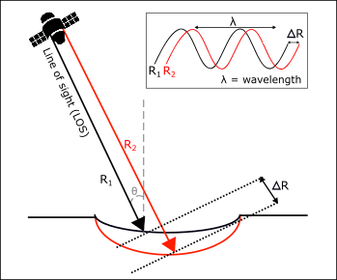

Figure : The fundamental InSAR principle; measurement of ground deformation via change in phase of a radar signal.

## Available InSAR Datasets

A number of satellite datasets are available for InSAR analysis, as summarised in Table 1. A key condition for accurate InSAR is frequent and consistent repeat measurements. The European Space Agency’s Sentinel-1 dataset is therefore a crucial resource in regularly and systematically capturing images for approximately the entire global landmass and making this data freely available at point of use. Other satellites can provide valuable data, often at higher resolutions, but are typically limited in terms of coverage or restricted due to licensing costs and constraints.

Table : Summary of available satellite datasets capable of InSAR and key attributes.

|  |  |  |  |  |  |
| --- | --- | --- | --- | --- | --- |
| Name | Attributes (approximate; varies with configuration; subject to change) | | | | |
| **Spatial Resolution,  (Range x Azimuth, m)** | **Typical Revisit Frequency (days)** | **Data Availability** | **Public  Availability** | **Coverage** |
| Sentinel-1 | 5 × 20 | 6 | 2014–present | Free at point of use | Systematically global |
| ERS-1, 2 | 20 × 5 | 35 | 1992–2000 | Free at point of use | Near global, but sporadic |
| ENVISAT | 20 × 5 | 35 | 2002–2012 | Free at point of use | Near global, but sporadic |
| COSMO-SkyMed | 1 × 1 to 3 × 3 | ~4 | 2007–present | Commercially | Near global, but sporadic |
| TerraSAR-X | 1 × 1 to 3 × 3 | 4–7 | 2007–present | Commercially | Near global, but sporadic |
| ALOS 1, 2 | 7 × 7 to 88 × 88 | 14-46 | 2006–2011, 2014–present | Limited | Near global, but sporadic |
| RADARSAT-1, 2 | 1 × 3 to 5 × 5 | 24 | 1995–present | Limited | Regional focus on Canada |
| SAOCOM | 10 × 10 to 30 × 30 | 8 | 2019–present | Limited | Regional focus on Argentina |

# Context and Motivation

## Nuclear Decommissioning Challenges

In the context of nuclear decommissioning, particularly within EDF Energy’s Advanced Gas-cooled Reactor (AGR) estate, Structural Health Monitoring (SHM) is of paramount importance. The monitoring of decommissioned AGR sites will be required for approximately 80-100 yrs after defueling has finished, which is why a low-cost repeatable solution is needed for continued site monitoring. The safe and effective decommissioning of ageing nuclear reactors relies on the early detection of any structural deficiencies or deformations that could lead to safety hazards. A failure to detect these issues promptly may not only compromise the decommissioning process but also pose serious risks to public safety and the environment.

## Monitoring Technologies

### Satellite Systems

Satellite systems, with their broad area coverage and regular revisit times, provide a consistent and comprehensive overview of large-scale structural changes over time. They can monitor extensive areas of infrastructure with the advantage of near real-time updates.

### UAV Systems

Unmanned Aerial Vehicles (UAVs) equipped with SAR systems offer the benefit of high-resolution data and operational flexibility, enabling detailed inspections of specific areas of interest. UAVs can capture fine-grained information that satellites might overlook, especially in regions where satellite imagery is limited by resolution or revisit frequency. This includes imaging areas that are obscured or shadowed in satellite imagery by overlapping targets due to the fixed satellite line-of-sight.

## Technical Background

### Software Automation

Integration of automated processing within the EDF Energy IT environment is essential for the system to deliver cost savings at scale. By automating the processing and analysis of structural health data, the project aims to reduce operational costs and enhance the value delivered to monitoring teams. Automation not only speeds up data analysis but also minimises human error, thereby ensuring more reliable and timely decision-making.

## Integrated Approach

The StARRS project enables a multi-scale approach to structural assessment by combining satellite and UAV-based monitoring. Satellite data offers regular, automated coverage over large areas without the need for on-site activity, while UAV systems provide flexible, high-resolution inspection of specific assets, including those in shadowed or complex structures. UAV surveys can be used for a more detailed investigation of any deformation or change phenomena detected in the broader satellite measurements. The use of independent sensing platforms also allows for cross-validation of results, improving confidence in the data. This combination of datasets therefore results in a more capable and reliable monitoring system than either approach alone.

# STARRS-Cloud

STARRS-Cloud is the development and demonstration of a highly automated remote sensing system for use in the UK nuclear decommissioning sector. The system aims to automate the provision of precise deformation monitoring provided by time series analysis of InSAR data.

A number of case studies for results are under active development in the **StARRS-Cloud Case Studies** [7] supporting document. Existing case studies for ancillary infrastructure such as road and rail can be found in literature [1].

## Project Scope and Objectives

The project aims to demonstrate the value of InSAR and remote sensing technologies in nuclear decommissioning, and demonstrate that this technology can be operationalised and integrated into EDF’s IT systems to support long-term site management. The following objectives were identified:

* Develop an automated cloud-based InSAR processing system capable of deriving deformation products from publicly available satellite datasets (e.g., Sentinel-1) with minimal manual intervention.
* Implement a user-friendly web interface that allows technical and non-technical users to access, visualise, and interpret geospatial deformation data across multiple sites.
* Ensure interoperability with EDF’s Microsoft Azure infrastructure, and business processes. Including tools for secure deployment, user management, and data segregation.
* Produce comprehensive technical documentation and training materials to facilitate independent operational use and long-term maintainability.
* Demonstrate value through real-world case studies, highlighting the value of insights that are uniquely provided by remote sensing.

## Cloud Environment

By utilising cloud infrastructure, the STARRS-Cloud system can process otherwise challenging quantities of satellite data efficiently and near-autonomously. The system has therefore been developed specifically for deployment in a Microsoft Azure cloud computing environment.

Azure provides enterprise-grade security, high availability, and scalability (for data processing across the national decommissioning estate). These qualities are key to reliable provision of long-term monitoring. Designing for Azure also removes barriers to interoperability with EDF’s own Microsoft Azure environment.

Importantly, this approach demonstrates the viability of the system within a nuclear IT system, enabling its use and management during long-term operations without relying solely on external specialists.

### Design Considerations

Developing software for nuclear decommissioning presents unique challenges. The system must be:

* **Reliable:** With a high level of uptime and consistent performance to ensure that monitoring is uninterrupted.
* **Future Proof:** Able to evolve with technological advancements and the long-term needs of the decommissioning process.
* **Secure:** Complying with stringent security standards to protect sensitive infrastructure data and adhere to regulatory requirements.

## System Architecture

The StARRS-Cloud system follows a microservices architecture to support modularity, maintainability, and scalable deployment. By separating key system functions into independent services, the architecture simplifies development, testing, and long-term management. It also allows components to be updated or replaced independently, which is particularly valuable for long-lived systems operating in regulated environments.

The main services include:

* A backend API for core business logic and data access controls
* A database capable of geospatial queries
* A reverse proxy for routing and additional access control
* A set of data-processing workers for task orchestration and producing InSAR results
* A frontend builder for deploying the user interface

A diagram of the service architecture can be found in Figure 2, showing a schematic view of how the services integrate to deliver results to decision-makers.

* 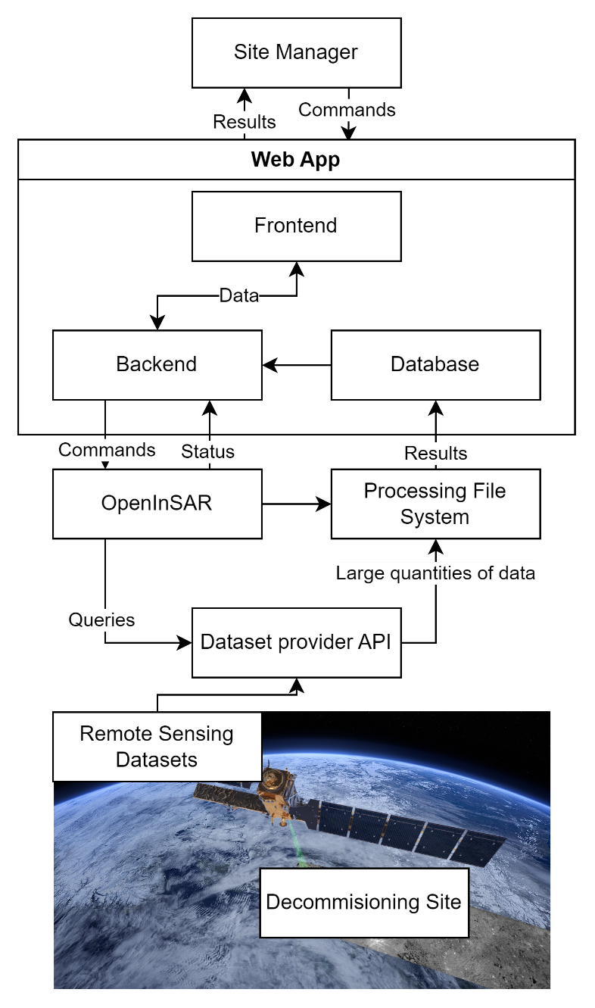
* Figure : StARRS-Cloud System Architecture.

Generally, each service is run in a ‘container’. Containerisation is a modern approach to software deployment that packages an application and its dependencies into an isolated unit. This isolation improves security, enhances reliability, and simplifies scaling, migration, and system upgrades. It also ensures consistent behaviour across different environments, regardless of the underlying host system.

In development and testing environments, these services are orchestrated using Docker Compose (a tool for multi-container applications). In pre-production and production, each service container is either deployed as-is on Azure or mapped to an equivalent managed Microsoft Azure service. This ensures compatibility between day-to-day development and enterprise deployment, leveraging the modularity and maintainability of the system design.

## User Interface

The STARRS-Cloud system provides a user interface that allows users to interact with the system and view the results of the analysis. The interface is designed to be user-friendly and intuitive, accessible and useful for both technical and non-technical users.

### Map Overview

The map overview is a main entry point for the STARRS-Cloud system, allowing users to intuitively explore the sites for which data has been collected.

The map context therefore provides a ‘dashboard’ view of the system, allowing stakeholders to inspect the decommissioning fleet from one web page, and allowing any alerts to be rendered geographically and give context to the user.

The map overview is demonstrated in Figure 3.

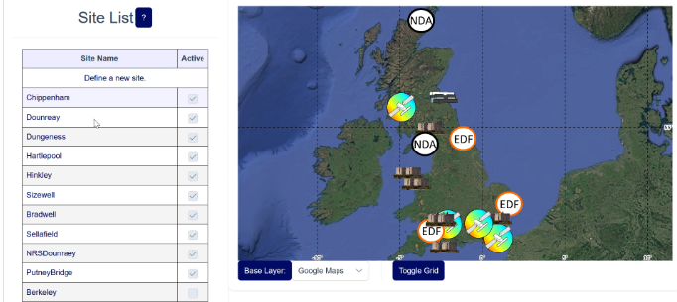

Figure : Map overview.

### Site configuration

An interface is provided for users to define and control the data-processing for each site, allowing a selection of different products to be generated and updated.

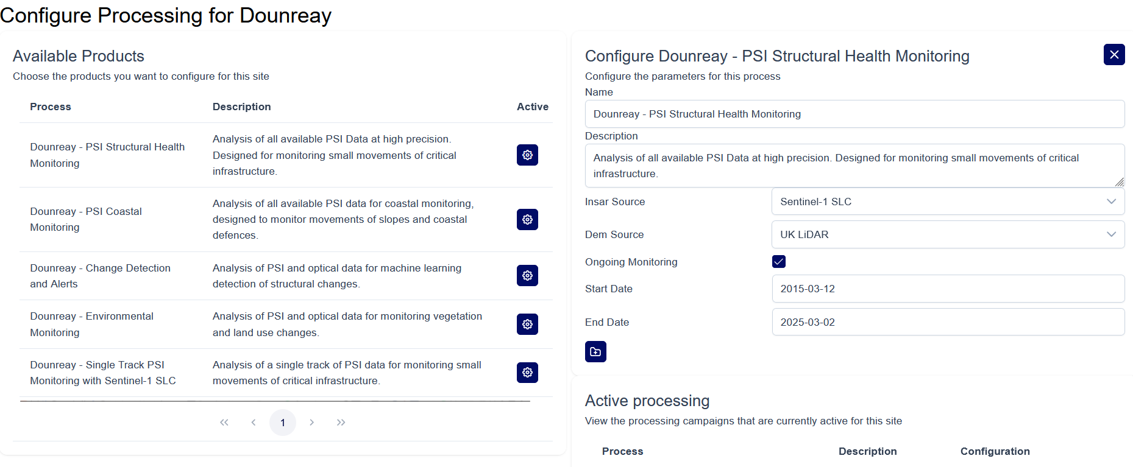

Figure : Site configuration

### PSI Viewer

A core feature is the ability to view results from PSI studies for decommissioning sites. A specific viewing tool has been developed for this purpose, and the current interface is shown in Figure 5.

A number of interactive tools are built into the viewer to provided additional functionality for user interaction:

* Time series displacement history graphs for each measured point.
* Selection between different result layers from different processing runs.
* Selection of base map.
* Control over map rendering parameters.
* Pre-set parameters for a number of site management use cases.
* Downloading results (for saving or importing into separate GIS).

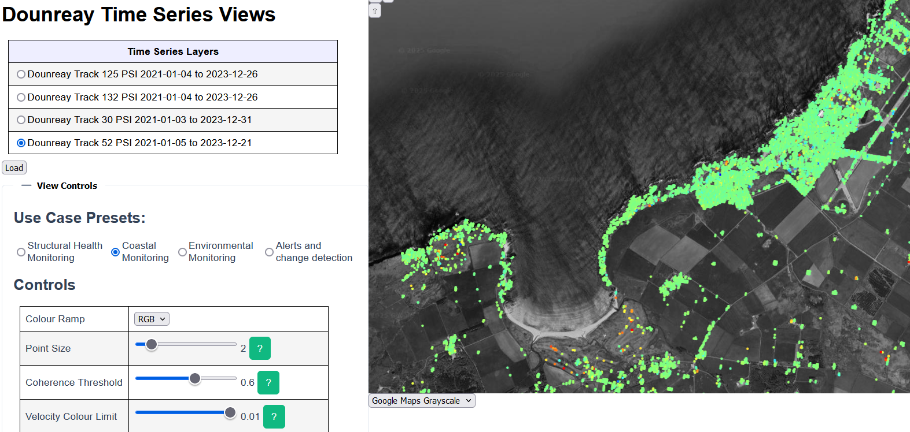

Figure : PSI Viewer.

## Technical Implementation

### Technology Stack

The specific technologies used to implement the architecture are as follows:

* **OpenInSAR**: The InSAR data processing system developed and used extensively at ICL.
* **Django**: A robust and extensible web framework used for implementing backend logic, APIs, authentication, and administrative interfaces. In production this
* **Vue.js**: A modern JavaScript framework used to build a responsive, user-friendly frontend interface.
* **PostgreSQL + PostGIS**: A relational database with spatial extension support, used for storing geospatial data and enabling efficient spatial queries and analysis.
* **NGINX**: A high-performance reverse proxy used to manage incoming HTTP requests, serve static assets, and provide HTTPS termination.
* **OpenAPI Specification**: Defines a formal contract for all API endpoints, enabling consistent documentation, client integration, and automated testing.
* **Playwright**: Microsoft’s widely popular system for end-to-end testing of web services.
* **Docker**: Used for containerisation, simplifying deployment and ensuring consistency across development, testing, and production environments.

The **StARRS-Cloud High-Level Architecture** [2] document provides further detail on the system design.

### Deployment and Management

Processes for the deployment and ongoing management of the STARRS-Cloud system are detailed in the **StARRS-Cloud Deployment Guide** [6]. This document provides instructions for launching the services through the Azure portal, validating system functionality, and managing results.

## Data Access Control Mechanisms

There may be commercial or security motivations for controlling access to the data products produced by StARRS-Cloud, in certain cases. There are several options available for this purpose depending on the level of segregation required. In general, access is controlled via a user’s Microsoft Entra ID identity and corresponding StARRS-Cloud account. By default, a user can only access data they have produced themselves.

### Group-Based Access

Access to data products within a shared deployment of StARRS-Cloud is managed using Django’s built-in group and permission system, which integrates with Microsoft Entra ID for authentication. Users are assigned to one or more Django groups, which control their access to data, views, and operations within the system.

Group membership can be aligned with organisational boundaries, site teams, or operational roles. A single user can be a member of multiple groups. Access to specific datasets, tools, and functionality is then restricted based on membership and inherently controlled by the application. This mechanism is easy to manage supports flexible delegation of access control without requiring full system-level isolation.

### Deployment and Infrastructure Options

Further separation can be achieved by Dedicated Instances or Database Sharding. With Dedicated Instances separate copies of the StARRS-Cloud system can be deployed for separate organisations, ensuring complete separation of any resulting data. However, each organisation will be responsible for deploying and maintaining their system. Sharing data between instances would require a manual-initiated procedure.

With Database Sharding, a single organisation remains responsible for operating an instance of the system but data is stored in distinct database instances and files systems specific to each separate organisation.

## Resource Management

### Cost Considerations

Resource allocation and cost management are critical components of the system. The STARRS-Cloud solution has been designed to optimise resource usage, which is vital given the long-term nature of nuclear decommissioning projects.

### Training and Support

To ensure a smooth transition and effective use of the new system, the project includes extensive hands-on training sessions and live demonstrations. These activities are aimed at equipping users with the knowledge and skills necessary to fully leverage the system’s capabilities.

## Supporting Documentation

Please see Section 3.1 of this document for an overview of supporting documentation providing greater detail on specific aspects of the system.

# STARRS-Ground

## System Overview

The StARRS-Ground system is an Unmanned Aerial Vehicle (UAV)-based and a ground-based platform designed to complement satellite observations by providing high-resolution, on-demand radar data acquisition for Structural Health Monitoring (SHM) during nuclear decommissioning. This system enhances the overall monitoring capability by focusing on detailed inspections that can be tailored to specific areas of interest.

## Project Scope and Objectives

### Primary Objectives

* Deliver high-resolution SAR imagery and monitoring data to supplement satellite radar observations.
* Enable flexible and targeted monitoring operations, with custom flight paths and deployment schedules.
* Integrate UAV-collected data with broader monitoring systems for comprehensive analysis and improved deformation data visualisation.

### Motivations

SAR is a remote sensing technique usually associated with satellites, produced by reflecting radar signals off a target area and measuring the two-way travel time back to the satellite. InSAR stacks multiple SAR images of the same target area acquired at different times to produce interferograms that show temporal surface displacement and other range changes.

Drones have emerged as a viable tool for low altitude monitoring in the past decade, with applications utilising photography, photogrammetry and Light Detection and Ranging (LiDAR). More recently, with improvements in the computational power of Software Defined Radar (SDR), the potential for drone-borne radar is evident.

Downscaling InSAR from satellites to ground-based systems such as drones provides:

* Improved spatial resolutions: a lower flight altitude relative to the target provides a reduced slant range and improved azimuth spatial resolution. This is useful for discerning closely spaced targets and buildings at congested sites, such as nuclear power stations.
* Improved temporal resolutions: the system may be flown on a daily, or sub-daily basis, contingent on adequate battery supplies, proper drone maintenance, and operator availabilities. Post-processing may occur immediately after the flight for near real-time data analysis. This allows for the creation of detailed deformation time-series to correlate with specific decommissioning and engineering activities, and weather events.
* Greater operational flexibility: custom flight paths to target locations that are obscured in the satellite data, through shadowing or overlay. The potential for indoor deployment, for interior structural monitoring and analysis.
* Enhanced customisation: the potential to use higher frequency radar signals for improved deformation sensitivity, or custom radar frequencies for target penetration into materials such as concrete and soils.
* Data fusion: with satellite InSAR (StARRS-Cloud) and other ground-based sensors (e.g. photogrammetry) in a Geographic Information System (GIS) provides a holistic overview for monitoring deformation at a range of spatial and temporal scales, with improved data visualisation.

### Major Activities

The following milestones and progress were achieved during StARRS-Ground, between April 2023 and April 2025:

* Software development for the drone and lab radar systems, including:
  + Raw radar data collection with higher bandwidths for improved spatial resolutions in the SAR data. This enables closely spaced targets, such as objects and buildings, to be better resolved.
  + SAR processing of the unique drone radar data for SAR image formation. This is a novel achievement in the literature and industry, with a limited number of similar drone SAR demonstrations.
  + Automated remote operation, data synchronisation and platform positioning corrections for the drone system. This drone software improves the experience for the end-user and is necessary for precision in the post-processing of fieldwork data.
  + Radar antenna performance testing, and material penetration and reflection testing, to better understand how radar signals from the ground-based systems interact with the built environment.
* Hardware development for the drone and lab radar systems, including:
  + Radar antenna optimisation - simulation, fabrication, and testing of new antenna materials (double-sided Copper Clad Laminate (CCL) and 3D printing) and dimensions for improved concrete penetration and performance.
  + A custom, portable ground-based SAR (GBS) system, for highly repeatable SAR data acquisition without drone deployment (where permissions to fly a drone are difficult to acquire).
  + Proof of concept of the drone radar system operations through fieldwork at a range of sites.
* Laboratory testing in the [electromagnetic anechoic chamber](https://www.imperial.ac.uk/bio-inspired-technology/facilities/em-lab/) for radar antenna performance testing, and static material reflection and penetration testing (dynamic materials testing is ongoing).
* Fieldwork expeditions to demonstrate the hardware and software functionality through automated flights for data collection at a range of sites, including:
  + Flint Hall Farm: an active landslide adjacent to the M25. Demonstrated the ability to image corner reflectors and other instrumentation in a predominantly rural environment.
  + The Satellite Applications Catapult Drone Test and Development Centre (DTDC): a mixed land-use site, with a runway, buildings, and adjustable corner reflectors.
* Documentation of decisions, processes and outputs, for integration and handover, including this report, and detailed manuals/user guides.

## System Components

### Hardware Overview

The hardware components of the StARRS-Ground system are listed below:

* UAV/drone radar system, including:
  + [DJI Matrice 600 Pro drone](https://www.dji.com/uk/support/product/matrice600-pro), chosen for its payload capability, stability, and configurability.
  + [Ettus E312 Software Defined Radar](https://www.ettus.com/wp-content/uploads/2019/01/USRP_E312_Datasheet.pdf), for raw radar data collection and signal processing.
  + [Emlid Reach RS+](https://www.3dxr.co.uk/sensors-c5/gps-gnss-c89/emlid-reach-c452/emlid-reach-rs-gnss-receiver-p2823) Global Navigation Satellite System (GNSS) receivers, for precise platform positioning.
  + Custom 5.4 GHz radar antennas for radar signal and transmission. Our [2023 paper](https://www.mdpi.com/2504-446X/7/3/215) in the journal Drones details the development of these antennas. Please see the **Radar Antennas User Guide** [10], for full details on how to design, simulate, build and test custom radar antennas.
  + Supporting communication and navigation systems, for flight automation and data synchronisation.

Figure 5 shows the drone radar system in operation, prior to take-off at Flint Hall Farm. Please see the **Drone Radar System User Guide** [9] for full details and specifications regarding this hardware system.

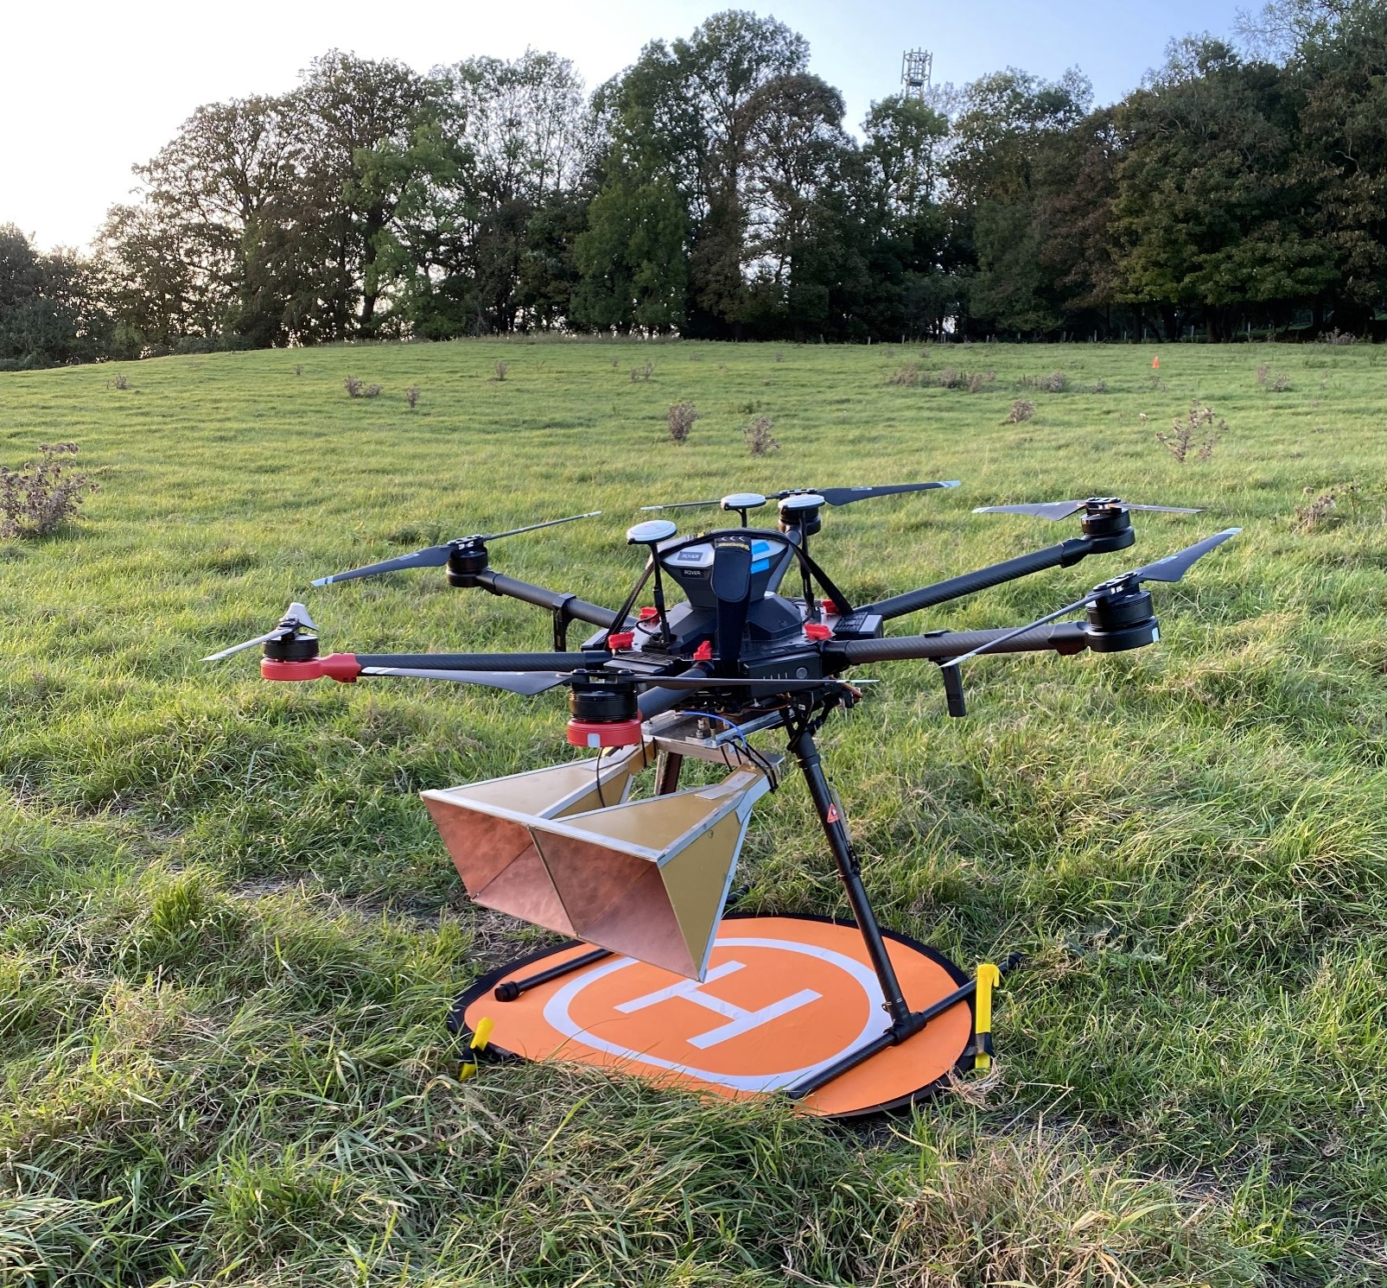

Figure : Drone radar system at Flint Hall Farm.

* Ground-based SAR (GBS) system, including:
  + 2.5 m automated linear rail.
  + Custom 2.75 GHz radar antennas for radar signal and transmission.
  + LibreVNA (Vector Network Analyser), for raw radar data collection and signal processing with improved bandwidth capabilities for improved image resolutions.

Please see the **GBS System User Guide** [11], for full details and specifications regarding this hardware system.

The operating principles of the drone and GBS are very similar, with consistent hardware (antennas, SDR/VNA) and software components. The drone system provides local to site-scale monitoring capabilities, whilst the GBS provides targeted, local-scale monitoring for specific targets and areas of interest.

### Software Overview

The software components of the StARRS-Ground systems are listed below and illustrated in Figure 7:

* UAV software, including:
  + Automated flight paths and mission planning.
  + Automated radar data collection through Radio Frequency (RF) triggering.
  + Data synchronisation with drone telemetry data.
* Post-processing software, including:
  + Precise platform positioning and flight path corrections through GNSS Post Process Kinematics (PPK).
  + SAR processing of raw drone radar data.

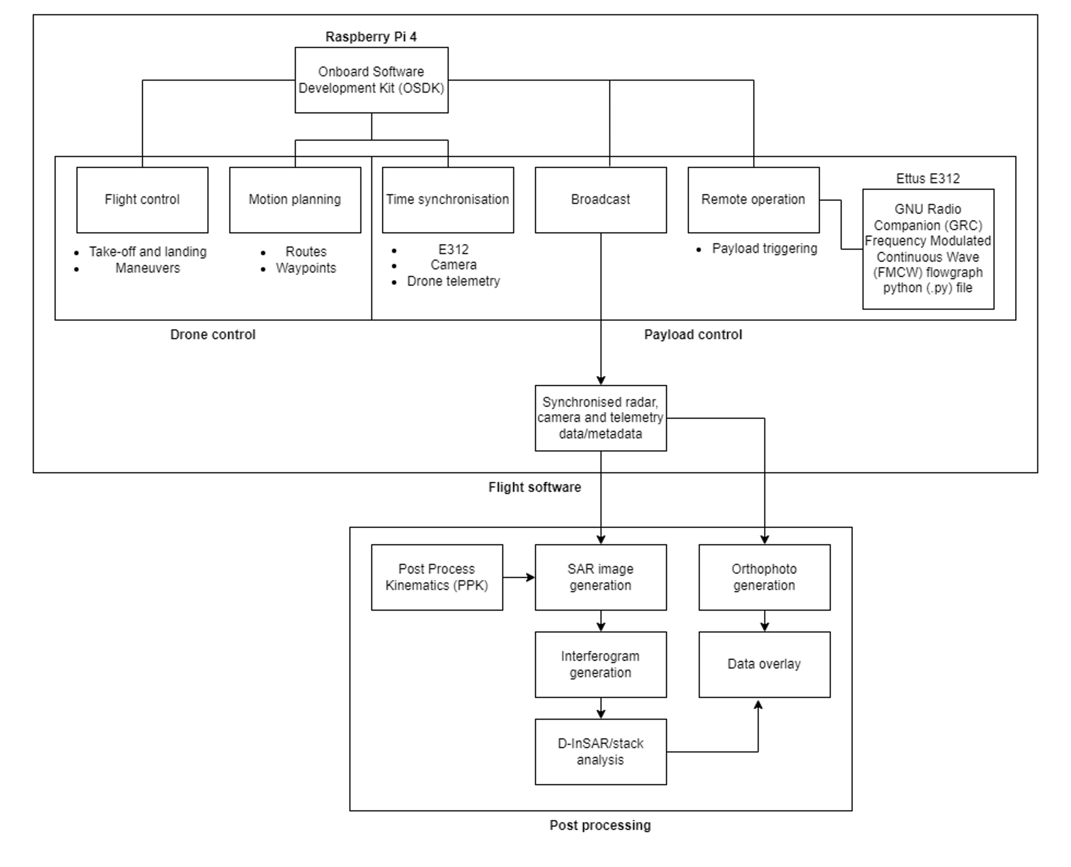

Figure : Drone radar system software overview flowchart.

* GBS software, including:
  + Linear rail control – speed and movement.
  + LibreVNA operations - data collection and processing.

Please see **the StARRS-Ground Software User Guide** [12] and the **StARRS-Ground** **GitHub repository** [13], for full details and specifications regarding this software.

## Implementation and Testing

### Laboratory Testing

Comprehensive laboratory testing in the anechoic chamber at Imperial has demonstrated the GBS’s capability to operate under simulated conditions with high precision. Key aspects tested include:

* Radar sensor and antenna testing and calibration, for improved performance and radar penetration of different target materials at various signal frequencies.
* Materials testing, to understand radar signal propagation mechanisms through concrete blocks and other materials found at nuclear sites. This includes testing of concrete blocks with varying densities, saturation content, and degrees of deformation. Ongoing tests are exploring the subsurface identification of rebar in concrete. Figure 8 shows the experimental setup for concrete block testing in the anechoic chamber.

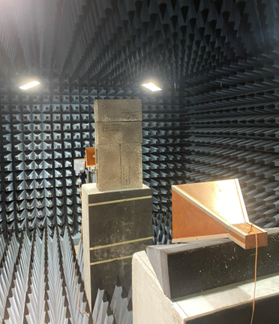

Figure : Concrete block testing experimental setup in the anechoic chamber.

Please see the **Laboratory Testing** **User Guide** [14]for full details of the laboratory testing methodologies and results for concrete blocks.

### Field Testing

Fieldwork results have validated the system’s performance in real-world scenarios, with successful UAV deployments providing actionable data. Key achievements include:

* Successful mission execution, with automated flight paths and data collection, and verification of the hardware and software components.
* Data collection accuracy, with validated positional accuracy in the post-processed drone data.
* System reliability in varied operational conditions, including high-winds and adjacent to high-risk infrastructure.
* Training of PhD researchers at Imperial for system operation, to develop training and demonstration procedures for greater ease of use.

Field testing was conducted at three sites:

* Flint Hall Farm, Surrey, UK: identified as a suitable case study location due to our industry connections at National Highways monitoring this active landslide, which poses a considerable safety risk to the adjacent M25 (Figure 9).
  + In 2021, two corner reflectors (CRs) were installed at the site to facilitate satellite InSAR monitoring of surface deformation (Figure 10). The site is ideal for drone flight tests for SAR imaging, being private land near London with no flight restrictions and having a mixture of natural and manufactured targets for SAR target detection and focussing.
  + Our [2024 paper](https://www.mdpi.com/2072-4292/16/20/3874) presented the first SAR image using our drone radar system at this site (Figure 11), with an improved spatial resolution compared to satellite SAR (Figure 12) for discriminating the various manmade targets on the slope.

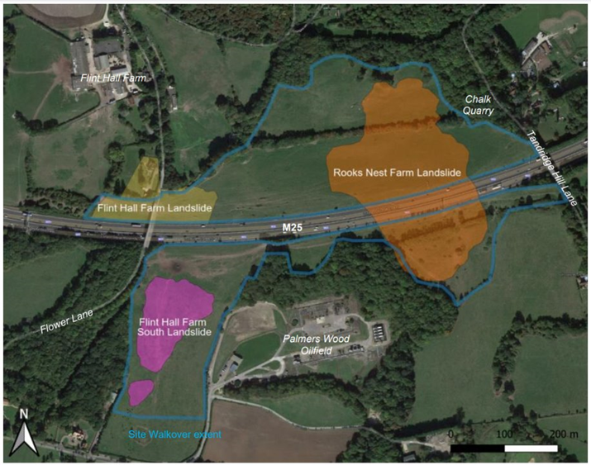

Figure : Landslide extents at Flint Hall Farm.

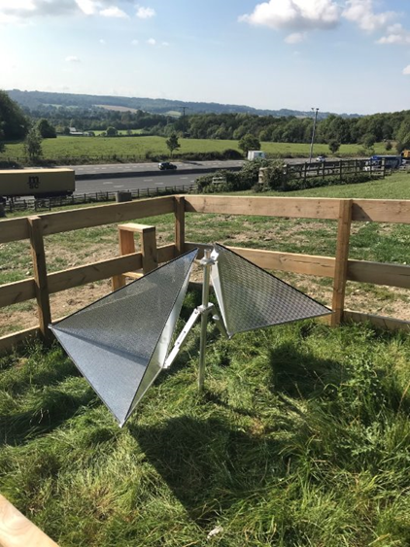

Figure : Corner reflectors at Flint Hall Farm.

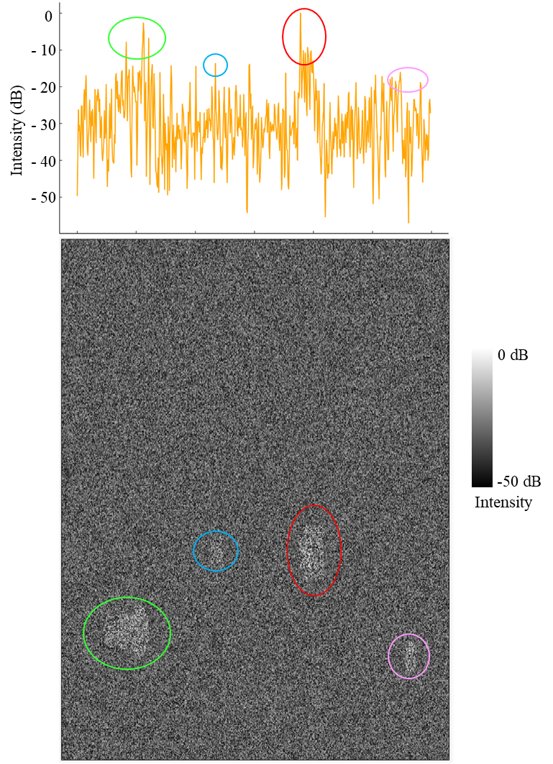

Figure : Drone SAR image range profile intensity graph, with circled target peaks (including corner reflectors (red) and other fenced areas for in situ instrumentation (green, blue, and pink), corresponding to the coloured, circled targets in the SLC SAR image from Flint Hall Farm. The range axes are approximately aligned.

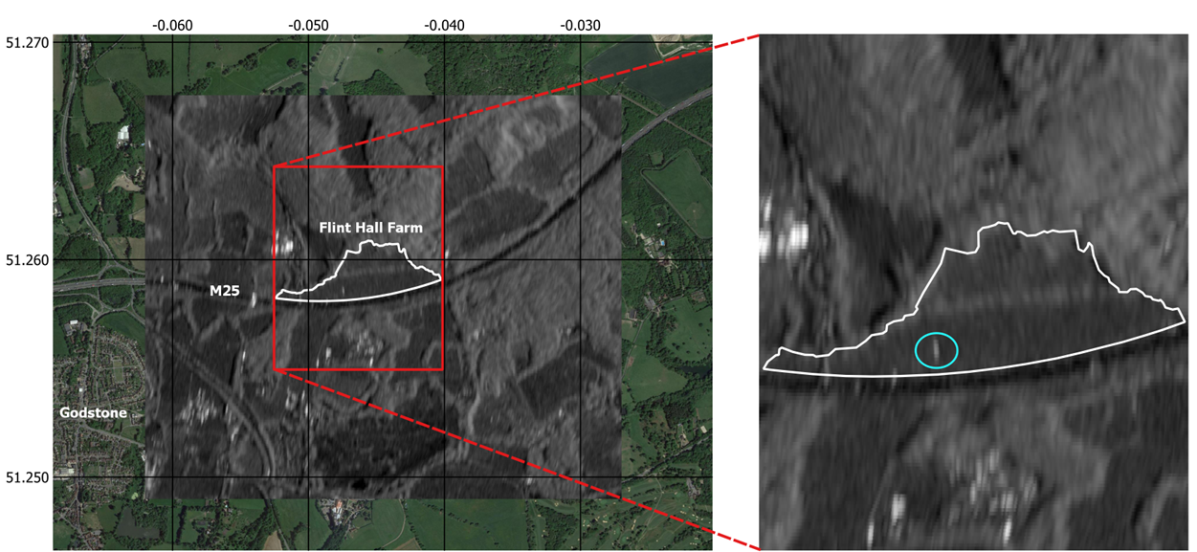

Figure : Sentinel-1 (satellite) average SAR amplitude for Flint Hall Farm (white boundary) from September 2021 to September 2023. The zoomed image boundary is denoted by the red box. The corner reflector and in situ instrumental pixels are circled in blue.

* Satellite Applications Catapult Drone Test and Development Centre (DTDC): mixed land-use site (Figure 12), including:
  + 270m runway and 4 launchpads, for flight training and demonstrations.
  + Hangars and workbenches, for hardware maintenance and development.
  + Various flying areas, including the sensor testing range (Figure 13) - mixed land-use, abandoned structures, and adjustable radar reflectors, which are very useful for testing and validating the drone InSAR capabilities.

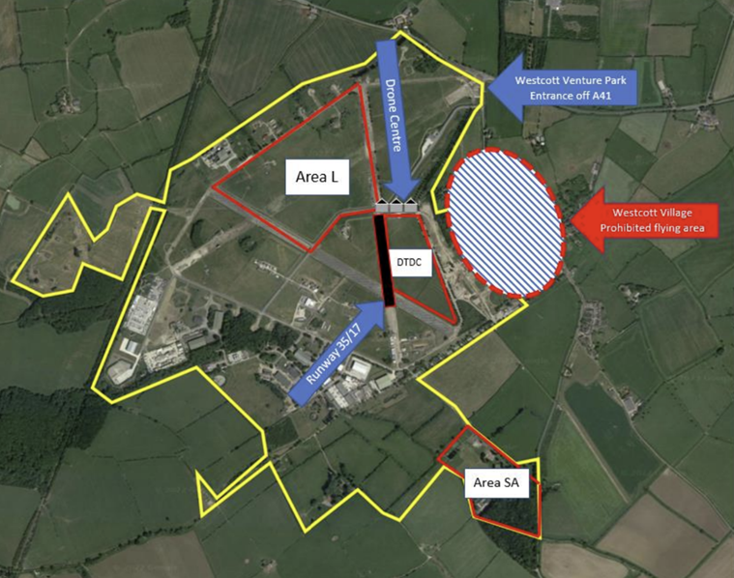

Figure : Drone Test and Development Centre Map.

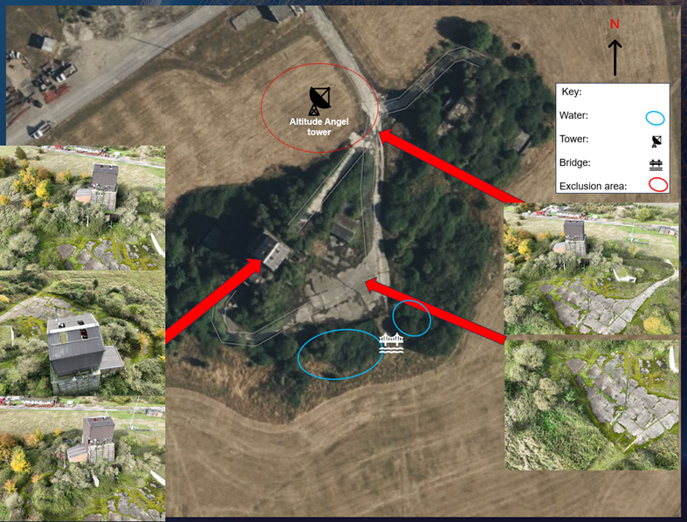

Figure : Sensor Testing Range, DTDC.

* Wormwood Scrubs (WWS):
  + An open-space in West London, with a dedicated area for drone flight.
  + Mixed land-use site, with grass, vegetation and the neighbouring Old Oak Common HS2 construction site.
  + An improved drone SAR image was achieved at this site, imaging the railway depot and construction site (**FIGURE**).

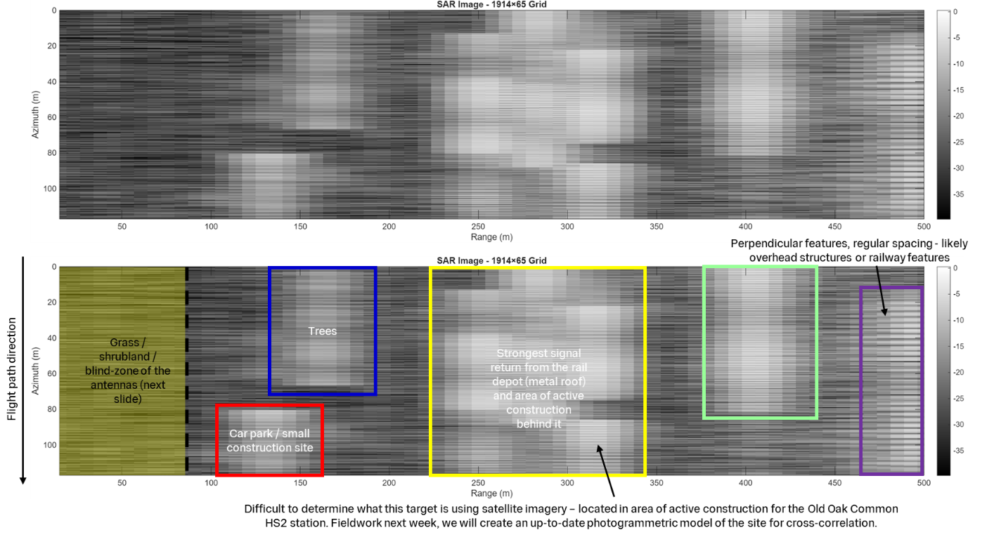

First drone SAR stacking

Please see the **Field Testing User Guide** [15] for full details of the fieldwork testing methodologies and results.

Several sites have been identified to support future system testing and data collection, including ageing radar stations, and schools with Reinforced Autoclaved Aerated Concrete (RAAC). Brighton Marina was also highlighted for future field testing; this site has a mixture of natural (cliffs, foreshore, grass fields) and manmade (marina arm, buildings, sea defences, undercliff walk) targets, for greater contrast in the SAR images compared to Flint Hall Farm. Furthermore, there is a known issue/movement at the marina arm (Figure 15) – therefore, this is a useful case study site to develop InSAR capabilities.

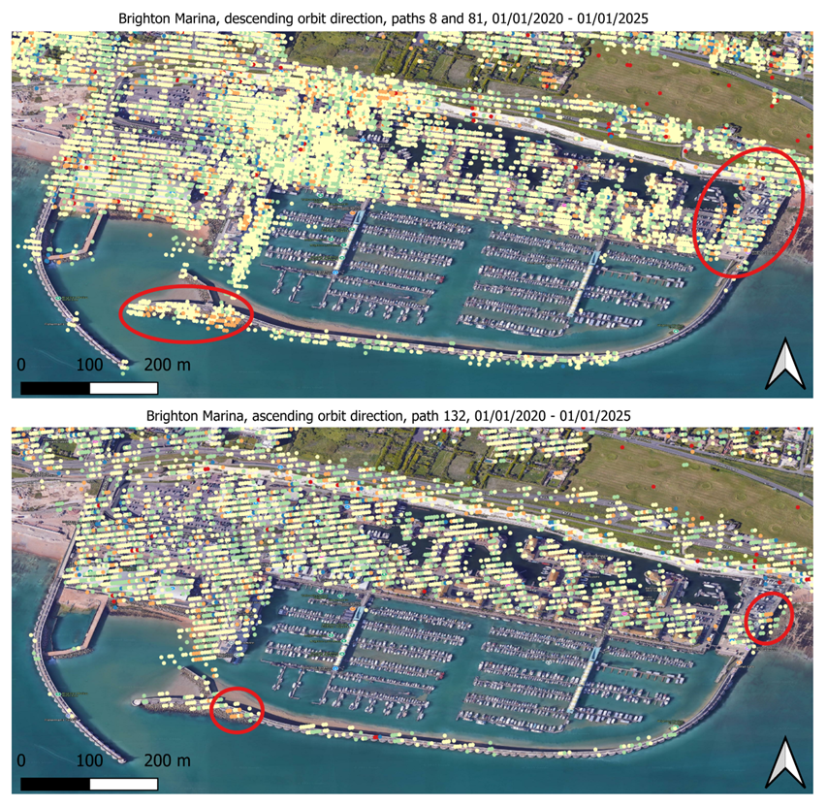

Figure : OpenInSAR Sentinel-1 InSAR results for Brighton Marina, 2020-2025.

## Applications and Use Cases

The ground-based systems developed throughout the StARRS-Ground project are tailored towards detailed, site-scale structural inspections, and are particularly useful for:

* Bridging the gap between site-regional scale monitoring provided by equivalent satellite systems, and the local-site scale monitoring required by site managers and engineers:
  + An area of interest may be identified using the satellite system and explored in greater detail and resolution using the ground-based systems. Alternatively, the ground-based systems may identify an area of interest, and the satellite system can be used to analyse the historical archive of data, to identify potential deformation trends. The GBS and drone systems provide local-site scale monitoring, whilst the satellite system provides site-scale-regional monitoring. Fusing these technologies and datasets ensures that site managers and engineers have a plethora of deformation monitoring data at a range of scales to inform their decision-making.
* Identifying subtle, millimetric structural deformations using InSAR:
  + Like satellite InSAR, drone InSAR stacks multiple SAR images to form interferograms and generate deformation outputs. Long-term drone InSAR is yet to be demonstrated in the literature or in industry and is the focus on ongoing work at Imperial. This requires a long-term fieldwork campaign for extensive data collection, and the development of a novel InSAR processing software for drone SAR data. This software will follow the processing chain for satellite radar data, but with adaptations for the drone-specific variables and data. The outcomes will include:

(a) The first drone interferogram (2 stacked SAR images) for differential-InSAR (DInSAR: simple before and after snapshot of deformation).

(b) The first long-term (several months) deformation analysis using multiple drone SAR images (20+) and novel drone InSAR processing techniques.

* Providing high-resolution insights for flagged areas of interest, by providing flexibility in deployment geometries and regimes:
  + The fieldwork campaigns have demonstrated the ability to conduct automated flight missions, with custom flight paths, including height, viewing angle, and speed. This operational flexibility allows the user to create bespoke monitoring campaigns for specific targets and areas - something which traditional satellite systems do not offer.
* Supporting critical decision-making in decommissioning operations:
  + The GBS and drone radar systems are additional tools for engineers to assess the long-term safety and compliance of sites undergoing decommissioning. Like satellite InSAR, the technologies are particularly well-suited to the manmade, concrete infrastructure found at nuclear energy sites.

## Training and Support

To ensure successful adoption and utilisation of the StARRS-Ground systems, the following training and support mechanisms are considered:

* Training plans: currently used to onboard and train new PhD researchers at Imperial, these plans will be revised and developed for end-users in the nuclear industry.
* Live demonstrations: end-users of the GBS and drone systems will require numerous, in-person demonstrations and hands-on training sessions, to become familiar with the technologies. These may take place at Imperial, the DTDC, or a suitable, alternative site.
* Post-deployment operational guidance: the systems developed during this project are novel and relatively complex, therefore post-deployment guidance and support will be required for end-users.
* Technical support documentation: this report refers to a series of appendices and user guides, which provide more in-depth information, specifications and instructions regarding the technologies developed throughout this project.

## Supporting Documentation

Please see Section 3.2 of this document for an overview of this comprehensive documentation.

# Integration

Integrating UAV and satellite datasets offers significant opportunities to enhance SHM through complementary insights and advanced 3D geospatial modelling. By combining the broad coverage of satellite imagery with the high-resolution capabilities of UAV data, a more comprehensive and detailed picture of structural integrity can be developed.

## Complementary Datasets for Structural Health Monitoring

* **Broad vs. Detailed Coverage:**
  + Satellite data, such as that from Sentinel-1, Sentinel-2, and Landsat, provide extensive, regular coverage that is ideal for monitoring large areas over time. In contrast, UAVs can capture high-resolution images that reveal fine-scale structural details, including minute deformations and surface anomalies. This combination enables a multi-scale assessment that leverages the strengths of both data sources.
* **Resolution and Flexibility:**
  + UAVs offer increased resolution and the flexibility to avoid issues such as image ‘shadowing’ caused by obstructions or unfavourable sun angles. Their higher sampling frequency allows for targeted inspections, especially in areas identified as potentially problematic by satellite monitoring.
* **3D Geospatial Models:**
  + The integration of UAV and satellite data facilitates the construction of detailed 3D geospatial models. These models enable analysts to visualise structural deformations and changes over time with greater accuracy, supporting more effective decision-making in the context of nuclear decommissioning. Advanced data fusion techniques can align and overlay data from the two sources, enhancing the accuracy and reliability of the models.
  + The topographic data for 3D models can be derived from several sources. One option is the use of DEFRA’s UK LiDAR dataset, which is available at resolutions up to 0.5m. For finer spatial detail, site-scale 3D models can be used such as those derived from UAV photogrammetry surveys or ground-based LiDAR.
  + For demonstration purposes, the 3D model shown in Figure 16 was derived from a UAV photogrammetry survey in Tooting, London. The photogrammetric image shows the road, buildings and surrounding infrastructure. This layer has been spatially combined with InSAR velocity data such that a user can query the deformation measured at any location through clicking a point on the 3D model. This data is provided in the pop-out window.

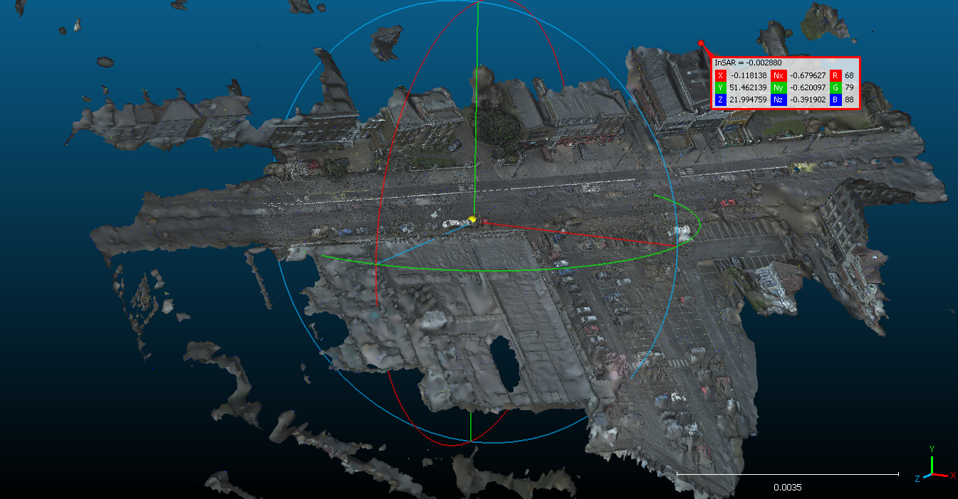

Figure : 3D model of Tooting, London.

## Benefits and Technological Considerations

* **Cost Efficiency and Operational Flexibility:**
  + Satellite data provides a cost-effective means of continuous, wide-area surveillance, while UAV operations, though potentially higher in cost per deployment, allow for precise interventions only when needed. This tiered approach offers different price points and levels of intervention, ensuring that resources are used efficiently.
* **Data Fusion Technologies:**
  + Specific technologies that could be employed for data fusion include:
    - **Machine Learning Algorithms:** To automatically detect and integrate anomalies from both datasets.
    - **Photogrammetry and LiDAR:** For creating high-resolution 3D models.
    - **Geospatial Information Systems (GIS):** To manage and overlay the different data layers for comprehensive analysis. These technologies not only improve the spatial accuracy of the models but also enhance the temporal resolution of monitoring efforts.

## Recommendations for Future Work

* **Enhanced Data Fusion Methods:**
  + Future work should explore advanced algorithms that can better harmonise data from disparate sources. This includes refining machine learning models to handle multi-modal data and developing more robust algorithms for 3D reconstruction.
* **Integration with Real-Time Monitoring:**
  + Consider integrating real-time UAV data with near real-time satellite imagery to provide dynamic updates to 3D geospatial models. This would allow for more timely interventions and a more proactive approach to maintenance.
* **Scalability and Automation:**
  + There is also a need to automate the data fusion process, integrating cloud-based processing systems that can handle large volumes of data and deliver actionable insights quickly. This aligns with the overall goal of reducing operational costs while improving the reliability and effectiveness of SHM.

In summary, the integration of UAV and satellite datasets not only provides a more detailed and comprehensive understanding of structural health but also supports cost-effective, scalable, and timely interventions. Future efforts should focus on refining data fusion technologies and real-time integration to further enhance these benefits.

# Conclusion

The StARRS project demonstrates the potential for integrating satellite and UAV-based SHM systems in nuclear decommissioning. By leveraging the extensive coverage of satellite platforms such as Sentinel-1 and Sentinel-2 alongside the high-resolution, flexible capabilities of UAVs, the project provides a robust framework for detecting and analysing structural deformations.

The development of complementary datasets, advanced 3D geospatial models, and automated data processing systems can enabled a multi-scale approach that enhances reliability and detail in monitoring critical infrastructure across the UK nuclear decommissioning estate.

Throughout the project, significant milestones were achieved across various components, including:

* The development of the **STARRS-Cloud system** for EDF’s Azure environment.
* The successful integration of web technologies to provide an intuitive interface for high-automated InSAR monitoring.
* The effective development and deployment of two **StARRS-Ground systems** (GBS and drone radar systems) at a range of field testing sites.

The StARRS project establishes a multi-scale platform for future innovations in SHM within the nuclear decommissioning sector. The projects ongoing efforts can focus on demonstrating the system’s operational value in improving safety, reducing site access requirements, and providing enhanced scrutiny and understanding of long-term site behaviour.

References

[1] P. J. Mason *et al.*, *C805 InSAR and Earth Observation techniques for infrastructure*. CIRIA, 2022.

[2] S. Agar, ‘StARRS-Cloud High Level Design Document’, Imperial College London, Dec. 2025.

[3] S. Agar, ‘StARRS-Cloud API Documentation’, Imperial College London, Dec. 2025.

[4] S. Agar, *insar-uk/OpenInSAR*. (Jun. 02, 2025). Accessed: Jul. 02, 2025. [Online]. Available: https://github.com/insar-uk/OpenInSAR

[5] S. Agar, ‘StARRS-Cloud User Manual’, Imperial College London, Dec. 2025.

[6] S. Agar, ‘StARRS-Cloud Deployment Guide’, Imperial College London, Dec. 2025.

[7] S. Agar, ‘StARRS-Cloud Case Studies’, Imperial College London, Dec. 2025.

[8] S. Agar, ‘StARRS-Cloud Operational Cost Estimates’, Imperial College London, Dec. 2025.

[9] A. Carpenter, ‘StARRS-Ground UAV Radar System User Guide’, Imperial College London, Dec. 2025.

[10] A. Carpenter, ‘StARRS-Ground Radar Antennas Specification’, Imperial College London, Dec. 2025.

[11] A. Carpenter, ‘StARRS-Ground Ground Based SAR System Specification’, Imperial College London, Dec. 2025.

[12] A. Carpenter, ‘StARRS-Ground Software User Guide’, Imperial College London, Dec. 2025.

[13] A. Carpenter, ‘StARRS-Ground Repository’, Imperial College London, Dec. 2025.

[14] A. Carpenter, ‘StARRS-Ground Laboratory Testing Guide’, Imperial College London, Dec. 2025.

[15] A. Carpenter, ‘StARRS-Ground Field Testing User Guide’, Imperial College London, Dec. 2025.

[16] A. Moreira, P. Prats-Iraola, M. Younis, G. Krieger, I. Hajnsek, and K. P. Papathanassiou, ‘A tutorial on synthetic aperture radar’, *IEEE Geosci. Remote Sens. Mag.*, vol. 1, no. 1, pp. 6–43, Mar. 2013, doi: 10.1109/MGRS.2013.2248301.

[17] R. Bamler, ‘Principles Of Synthetic Aperture Radar’, *Surveys in Geophysics*, vol. 21, no. 2, pp. 147–157, Mar. 2000, doi: 10.1023/A:1006790026612.

[18] B. Osmanoğlu, F. Sunar, S. Wdowinski, and E. Cabral-Cano, ‘Time series analysis of InSAR data: Methods and trends’, *ISPRS Journal of Photogrammetry and Remote Sensing*, vol. 115, pp. 90–102, May 2016, doi: 10.1016/j.isprsjprs.2015.10.003.

[19] M. Crosetto, O. Monserrat, M. Cuevas-González, N. Devanthéry, and B. Crippa, ‘Persistent Scatterer Interferometry: A review’, *ISPRS Journal of Photogrammetry and Remote Sensing*, vol. 115, pp. 78–89, May 2016, doi: 10.1016/j.isprsjprs.2015.10.011.

[20] A. Ferretti, C. Prati, and F. Rocca, ‘Permanent Scatterers in SAR Interferometry’, *IEEE TRANSACTIONS ON GEOSCIENCE AND REMOTE SENSING*, vol. 39, no. 1, p. 13, 2001.

[21] A. Ferretti, A. Fumagalli, F. Novali, C. Prati, F. Rocca, and A. Rucci, ‘A New Algorithm for Processing Interferometric Data-Stacks: SqueeSAR’, *IEEE TRANSACTIONS ON GEOSCIENCE AND REMOTE SENSING*, p. 12, 2014.